Work done on November 7, 2008-11-07
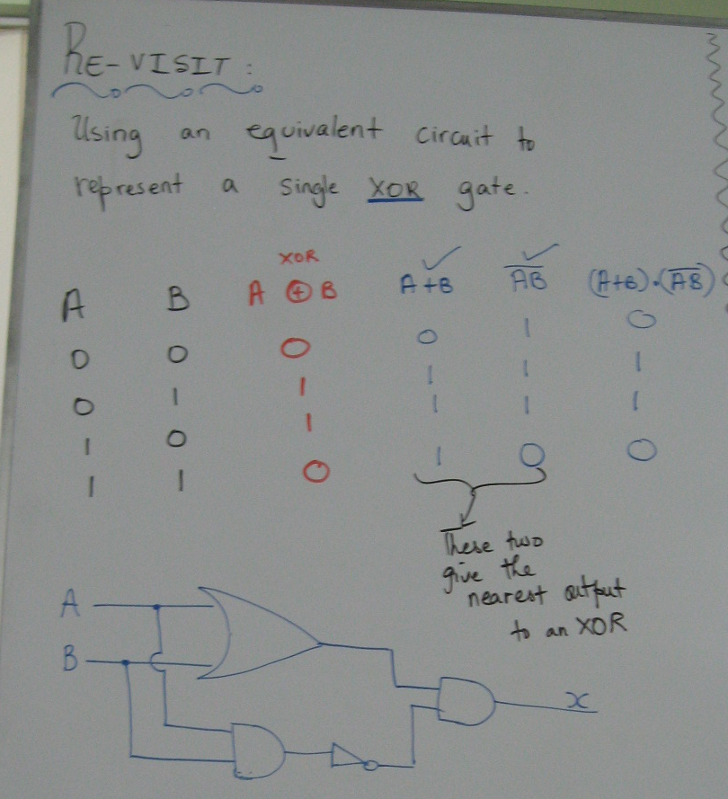

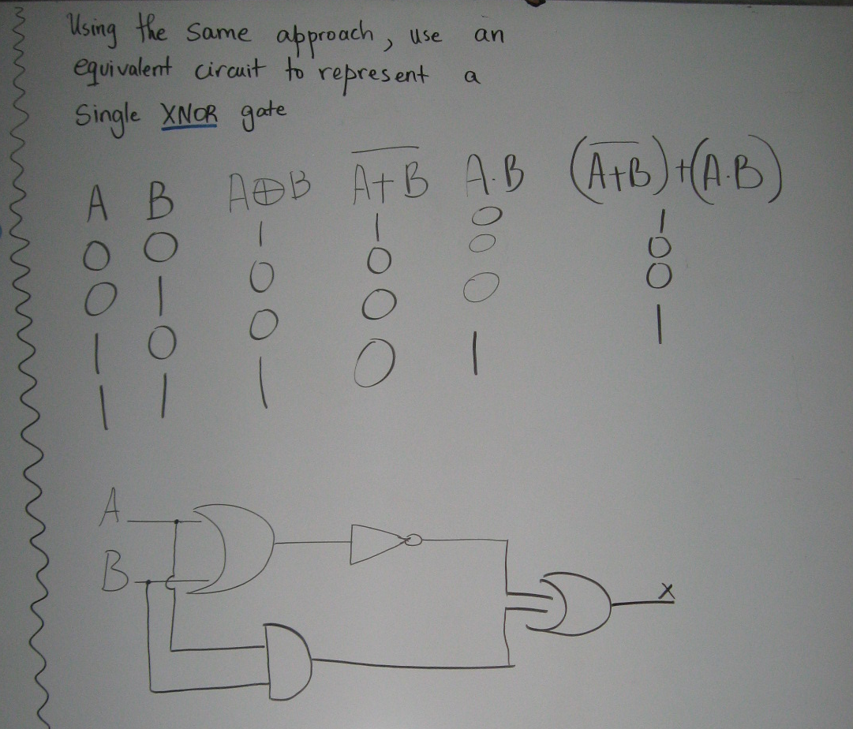
Writing the code for the sort discussed in the previous class.

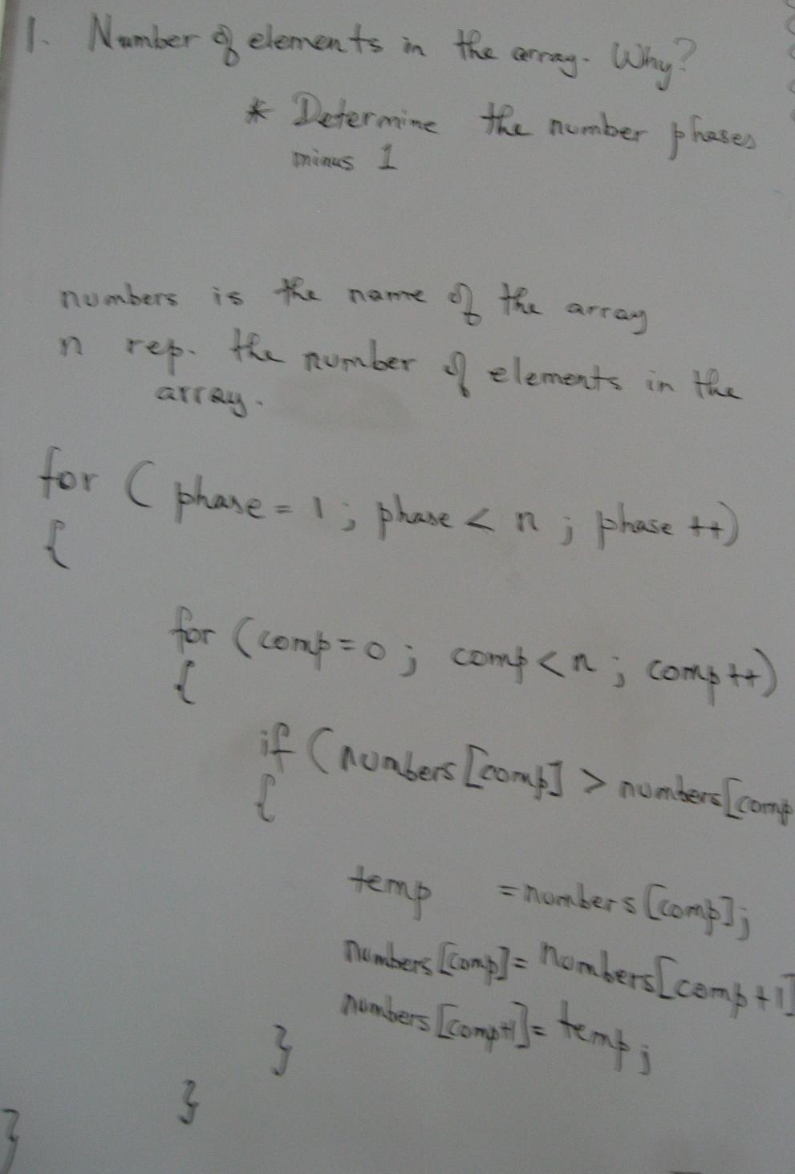

The sort was a partial representation of a Bubble Sort. This was discussed in further details and then the following site was shown (it was an animation of a Bubble Sort):

